[Company address]

SCHEDULE AT A GLACE

PACE Day - November 1, 2018
Time |  | Location
8:00 - 9:00 AM | Registration/Check-In | Registration Area
8:00 - 9:00 AM | Continental Breakfast | Ballroom
9:00 - 9:10 AM | Welcome Comments: Carolyn Jones, Acting President, LaTESOL | Ballroom
9:10 - 10:00 AM | Plenary Speaker: Dr. Brenda Custodio Supporting Students with Interrupted Formal Education | Ballroom
10:00 - 11:20 AM | Workshop: Principles and Skills for Working with Trauma-Exposed English Language Learners | Ballroom
11:30 AM-12:20 PM | Concurrent Sessions | Rooms 202, 203, 204, 205, 206
12:30-1:20 PM | Luncheon Speaker: Pat Austin "Between Cultures, Between Places” The Role of Children’s Books in the English Language Classroom | Ballroom
1:30-2:20 PM | Concurrent Sessions | Rooms 202, 203, 204, 205, 206
2:30-3:20 PM | Concurrent Sessions | Rooms 202, 203, 204, 205, 206

SCHEDULE AT A GLACE

LaTESOL Conference - November 2, 2018
Time |  | Location
8:00 - 9:00 AM | Registration/Check-In | Registration Area
8:00 - 9:00 AM | Continental Breakfast | Ballroom
9:00 - 9:10 AM | Welcome Comments: Carolyn Jones, Acting President, LaTESOL | Ballroom
9:10 - 10:00 AM | Keynote Speaker: Dr. Sydney Snyder “Advocating for Diverse ELs in Louisiana: Issues and Strategies" | Ballroom
10:10 - 11:00 AM | Workshops Part 1: Bob Schoenfeld and Jennifer Lebedev | Ballroom and Room 206
11:00 AM - 12:20 PM | Workshops Part 2: Bob Schoenfeld and Jennifer Lebedev | Ballroom and Room 206
11:00 AM - 12:20 PM | Concurrent Sessions | Rooms 202, 203
12:30 - 1:30 PM | Luncheon Speaker: Dr. Stacy Overstreet "Creating Trauma-Informed Schools: Rationale for Use with ELLs"
1:30 - 2:20 PM | Concurrent Sessions | Rooms 202, 203, 204, 205, 206
2:30-3:20 PM | Concurrent Sessions | Rooms 202, 203, 204, 205, 206
3:45 - 4:30 PM | LaTESOL Annual Meeting & Election of Officers | Room 206

PACE Day – November 1, 2018

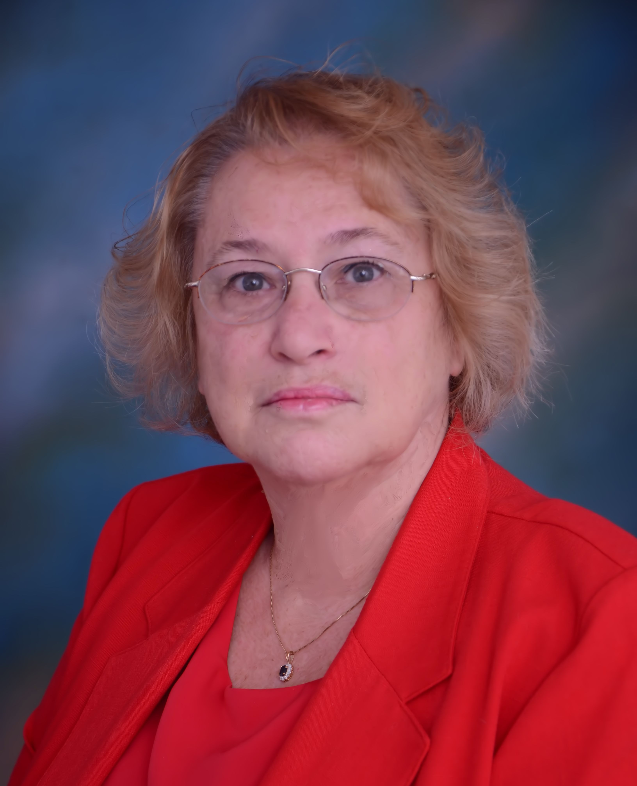 | Brenda Custodio, Ph.D.  9:00 – 10:00 AM  Location: Ballroom  SUPPORTING STUDENTS WITH INTERRUPTED FORMAL EDUCATION

Plenary Session Description: Students with interrupted education (SIFE) constitute up to 20% of our new arrivals at the P-12 level, and probably even more of the students in our adult ESL programs. This session will focus on how best to support these students. Dr. Custodio will share information and experiences, as well as research, which was recently compiled into the book, Students with Interrupted Formal Education: Bridging Where They Are and What They Need, by Corwin Press (co-authored with Judith B. O’Loughlin). The book provides essential background on factors leading to interrupted education, guidance on building internal resilience for long-term social and emotional health, and recommendation for creating supportive environments for all students.

Afternoon Session: MORE GUIDANCE ON BUILDING INTERNAL RESILIENCE FOR LONG-TERM SOCIAL AND EMOTIONAL HEALTH

Time: 11:30 AM to 12:20 PM Location: Room 206
Intended Audience: All

Description: Many of our English learners have experienced traumatic events, either before entering the US or while they are here. This session will define resilience and look at practical activities that a classroom teacher can do to help students tap into their inner resources in order to build resilience.

Dr. Brenda Custodio is retired from Columbus City Schools (Ohio) where she served as a middle and high school ESL teacher, a district-level coach for secondary ESL teachers, and a building administrator of a newcomer secondary academy. She currently teaches at the Ohio State University as well as serving as an educational consultant for several school districts. Dr. Custodio is a frequent presenter at state and national conferences on developing literacy for English learners, strategies for working with immigrant newcomers, and supporting students with interrupted education, especially refugees.

PACE Day – November 1, 2018  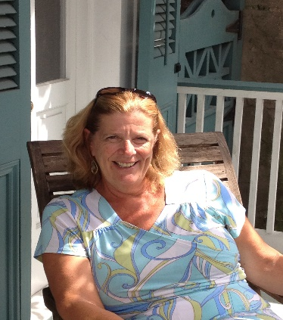 | KATHLEEN WHALEN  10:00 – 11:20 AM Location: Ballroom  WORKSHOP: PRINCIPLES AND SKILLS FOR WORKING WITH TRAMA-EXPOSED  ENGLISH LANGUAGE LEARNERS

Workshop Description: The workshop will address a variety of issues and activities directed toward working with English Language Learners or youth who have had an interruption in their schooling. ACEs related to English Language Learners will be reviewed, along with a brief overview of the affects of trauma and toxic stress on the brain. Some specific brain break activities (activities with various levels of physical movement) will be demonstrated.

The workshop will also address the six principles of trauma-informed schools, including a discussion related to the challenges of the students trying to adapt to a new language and new culture, perhaps after experiencing toxic stress or trauma. Finally, four separate strategies for working with these students will be addressed. Teacher's will participate in activities related to each strategy and receive tip sheets and resources for each, along with a discussion of how many of these activities require little English and can help students learn to regulate their emotions to facilitate learning.

Afternoon Session: SELF-CARE FOR TEACHERS OF ELLS IMPACTED BY TRAUMA
Time: 1:30 - -2:20 PM Location: Room 206 Intended Audience: All
Description: When teachers are working with students who have been impacted by trauma, it is important to consider the impact it can have on the teachers themselves. Exposure to student’s traumatic experiences can make the adults who work with them vulnerable to developing their own emotional or behavioral challenges. However, there are several researched based prevention strategies that can be employed to protect against or limit secondary traumatic stress. This session will provide examples of many of these strategies as well as opportunities to practice these self-care activities with the intention of improving or restoring health and well-being. Participants will leave the session with a trauma-informed action plan and resources to further develop a self-care practice.

Kathleen Whalen, LCSW-BACS, MEd is the Project Director for Safe Schools NOLA, a National Institute of Justice funded study of the use of trauma-informed approaches in schools. The goal of this research study is to determine how school personnel and students respond to trauma-informed activities at their school, which include professional development training, coaching, and organizational support in trauma-informed approaches. Kathleen has worked in many roles with New Orleans Public Schools (NOPS), including elementary school teacher, school social worker, lead team member in a day treatment center, and school representative in juvenile court. In addition to her 30-year tenure with NOPS, Kathleen was the Psychosocial Program Director with Save the Children in New Orleans, through which she supervised a staff of school-based social workers who worked to build resilience and coping skills addressing stress and trauma associated with Hurricane Katrina.

PACE Day – November 1, 2018

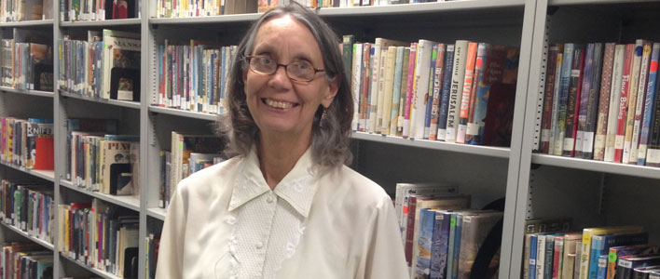

Dr. Pat Austin

12:30 PM

Location: Ballroom

LUNCHEON ADDRESS

BETWEEN CULTURES, BETWEEN PLACES: THE ROLE OF CHILDREN’S BOOKS IN THE ENGLISH LANGUAGE CLASSROOM

Luncheon Session Description: Dr. Austin will share thoughts on the role of children’s books and their impact on English Language Learners. She will also highlight specific books that are relevant to the teachers of ELLs.

Afternoon Session: BOOKS TO BUILD BRIDGES OF UNDERSTANDING

Time: 2:30 to 3:20 PM Location: Room 202

Intended Audience: All

Description: English language learners and native speakers alike benefit from dialogue as they listen to and read books that address the immigrant experience. In this session, participants will hear about a wide array of books to ignite discussions and will have the opportunity to interact.

Pat Austin, professor of children’s literature, curator of the UNO children’s library, and program coordinator of English education at the University of New Orleans, has won the International Literacy Association’s Arbuthnot Award, given to members who are deeply engaged in preparing teachers and librarians. She is UNO’s leading advocate for quality children’s literature.

PACE Day – NOVEMBER 1, 2018
CONCURRENT SESSIONS
11:30 AM – 12:20 PM
THE POWER OF LANGUAGE FOR LIFELONG SUCCESS  JESSICA BORDELON  Location: Room 202  Intended Audience: Intercultural Communications, All Levels  Description: This session encourages teachers to not only present grammar skills and vocabulary but to also use their own cultural knowledge and experience to explain the underlying meaning implied with each language skill. In this workshop, various grammar forms and vocabulary will be presented to attendees for discussion and creation of a sample lesson plan that can be used in the classroom. Attendees will build lesson planning skills they can apply to their language classrooms. |  | BARRIERS INHIBITING ELL PARENTAL ENGAGEMENT  ANGELA BRADLEY  Location: Room 204  Intended Audience: K-12, Research  Description: This presentation contains research on the common barriers faced by ELL parents regarding their participation in their children’s educational experience: communication barriers, economic challenges, challenges encountered through the process of immigration, and differences in cultural expectations of education. Educators must formulate a more holistic foundation of understanding from which to guide practical solutions within the school setting to increase parental engagement.
ELA GUIDEBOOKS SCAFFOLDS FOR ENLISH LEARNERS  CRYSTAL ARCINEAUX & ESTHER PEREZ ZEMMELS  Location: Room 203  Intended Audience: Bilingual Ed, Reading  Description: Aligned to the Louisiana  Department of Education's ELA Guidebooks and  the Diverse Learner Guide, scaffolds were  written to support specific units in grades 3-8.  The uniqueness of  the scaffolds is that they are not mere  suggestions, but they are completed and ready to use  for teachers. Each slide that  a teacher uses for instruction is embedded with  the scaffolds. This work was presented at  Teacher Leader Summit 2018 and received  excellent reviews. |  | TECHNOLOGY AND ONLINE TOOLS FOR THE MAINSTREAM TEACHER OF ESL/ELL/EL STUDENTS  DENISE THOMAS AND MARISSA BEJARANO-FERNBAUGH AND REBECCA TULLOS  Location: Room 205  Intended Audience: Secondary Education  Description: This presentation will help mainstream teachers to effectively teach their English Language Learners using technology and online tools. Teachers will leave with resources they can use in their classroom no matter the number of ELL students they teach. The presentation will explore what a technology rich classroom for ELL and native English speakers would look like.
MORE GUIDANCE ON BUILDING INTERNAL RESILIENCE FOR LONG-TERM SOCIAL AND EMOTIONAL HEALTH

DR. BRENDA CUSTODIO

Location: Room 206

Intended Audience: All

Description: Many of our English learners have experienced traumatic events, either before entering the US or while they are here. This session will define resilience and look at practical activities that a classroom teacher can do to help students tap into their inner resources in order to build resilience.

CONCURRENT SESSIONS
1:30 – 2:20 PM
USING STORYBIRD TO ENHANCE STUDENT WRITING  B “AJO” STEWART  Location: Room 202  Intended Audience: Elementary Ed; Writing  Description: Tap into students’ love of technology and unleash their creativity using Storybird.com This hands-on workshop walks participants through the process of creating class assignments and teaching students how to write and share their stories. One of the reasons this platform is so engaging is that artists upload their images for writers to use. The end result is a beautifully illustrated written work that students and teachers can be proud of. |  | NO MORE CRICKETS IN CLASS: HOW TO GET STUDENTS SPEAKING AND PARTICIPATING IN THE TARGET LANGUAGE  JUDITY ROWLEY  Location: Room 203  Intended Audience: Speaking; K-12  Description: Participants will learn some common barriers to participation and how to structure classes so ESL students will fully engage. We will discuss strategies for preparing students to speak, the role of vocabulary, accountability, community, and group work structures that lead to full engagement of all students.
SUPPORTING A TIER 1 CURRICULUM FOR Els AND TIER 3 STUDENTS  ALEXANDRA HORNER  Location: Room 204  Intended Audience: Elementary Education  Description: In this session, participants will learn how to increase the value of the ELA Guidebooks, making them accessible to all learners, including Tier 3 Students. Specifically, we will examine scaffolds for language demands which support students while maintaining rigorous academic content and attaining grade level standards. All activities are aligned to the objective of each lesson and unit goal objectives. Examples from a scaffolded unit will be provided, along with templates for teacher use. |  | EL SCAFFOLDS FOR 4TH GRADE GUIDEBOOKS – AMERICAN REVOLUTION UNIT  JENNIFER KELLEY, MONICA VAUGHN-FLAM AND VICTORIA ORDONEZ  Location: Room 205  Intended Audience: Elementary Ed; Curriculum Development  Description: This presentation will present suggested scaffolds for beginning level ELs for the La Guidebook 4th Grade Unit The American Revolution. Participants will learn where to start for planning scaffolds, review suggested unit scaffolds, have opportunities to discuss ideas and concerns with scaffolding, as well as receive resources to support planning, development, and strategies to scaffold.
Afternoon Session: SELF-CARE FOR TEACHERS OF ELLS IMPACTED BY TRAUMA  KATHLEEN WHALEN/TULANE  Time: 1:30 - -2:20 PM  Location: Room 206 Intended Audience: All  Description: When teachers are working with students who have been impacted by trauma, it is important to consider the impact it can have on the teachers themselves. Exposure to student’s traumatic experiences can make the adults who work with them vulnerable to developing their own emotional or behavioral researched based prevention strategies that |  | challenges. However, there are several can be employed to protect against or limit secondary traumatic stress. This session will provide examples of many of these strategies as well as opportunities to practice these self-care activities with the intention of improving or restoring health and well-being. Participants will leave the session with a trauma-informed action plan and resources to further develop a self-care practice.
CONCURRENT SESSIONS
2:30 – 3:20 PM
BOOKS TO BUILD BRIDGES OF UNDERSTANDING  DR. PAT AUSTIN  Location: Room 202  Intended Audience: All  Description: English language learners and native speakers alike benefit from dialogue as they listen to and read books that address the immigrant experience. In this session, participants will hear about a wide array of books to ignite discussions and will have the opportunity to interact. |  | INCREASING YOUR CULTURAL COMPETENCY FOR THE ESL STUDENT: A PANEL DISCUSSION/DIALOGUE  SHARON MOSCOSO & CURRIN WALLIS  Location: Room 203  Intended Audience: Adult Education  Description: Catholic Archdiocese of New Orleans provides English as a Second Language (ESL) and Citizenship classes to hundreds of adult learners from over forty countries each year at sites throughout Orleans, Jefferson, and St. Tammany parishes. Our ESL and Citizenship classes provide a key component for integrating into the American society for both immigrants who have recently arrived and those who have been in this country for several years. We will  Discuss some of the barriers facing immigrant ESL learners, strategies to address them, and learn about how Catholic Charities Archdiocese of New Orleans is using a more holistic approach for student success.
INCREASING READING ACHIEVEMENT FOR MS/HS ELL STUDENTS  WAYNE EICHEN, PEARSON EDUCATION  Location: Room 204  Intended Audience: Secondary Ed; Reading  Description: iLit ELL, a device-based reading program, promotes 2 years reading growth in one year. iLit contains 3,000 ebooks, translations in 47 languages, uses culturally relevant content written for MS and HS, has SIOP strategies embedded in the lesson plans, with research provided by Jim Cummins and other Reading Researchers and engages students so they want to read. |  | WHY TEACH WITH THE HELP OF IMAGINE LEARNING? IT’S NOT JUST FOR ENGLISH LANGUAGE LEARNERS  ELIZABETH THOMPSON AND JOHN EDWARDS, IMAGINE LEARNING  Intended Audience: Room 205  Description: All teachers have access to all of the printable stories and lesson plans offered in the program. With just a click of the mouse, a teacher has access to books on all reading levels. The students can work on this as a group or individually. Say goodbye to one-size-fits-all instruction and hello to a strategic, research-based curriculum that meets students at their own level.
A FIVE-DAY ELL LESSON PLAN ON A FRIENDLY LETTER, TRANSCRIBING LYRICS OF THREE SONGS ABOUT LETTERS, AND CULMINATING IN AN ESSAY TO COMPARE AND CONTRAST THE SONGS' MEANINGS.  RON CARON  Location: Room 206  Intended Audience: K-12; Writing  Description: Want a weeklong, on going lesson plan to educate, enliven, and entertain your ELLs? This session will present one that addresses the L.E.L.D.S. (La. English Language Development Standards) with content and language objectives in all four realms: reading, writing, speaking, and listening. Students will write letters for mailing (with envelopes and stamps), and then listen to and transcribe song lyrics, e.g., The Box Tops' song "The Letter", and then memorize, |  | summarize, compare, and contrast the lyrics in an essay, and finally, the use of technology with a WORD document in the form of a revised essay. There will be vocabulary along the way: salutation, greeting, closing, lyrics, rhyme, gist, summary, quotes, evidence, chorus, etc. Complete lesson plan handouts will be provided to all attendees.

LaTESOL Conference – November 2, 2018

KEYNOTE SPEAKER

Sydney Snyder, Ph.D.

9:00 – 10:00 AM

Location: Ballroom

ADVOCATING FOR DIVERSE ELs IN LOUISIANA: ISSUES AND STRATEGIES

Keynote Presentation Description: In this session, Dr. Sydney Snyder will share her vision of advocating for ELs, highlight key advocacy issues for ELs K-adult in Louisiana, and suggest practical strategies for educators to foster equity for ELs in the state.
Sydney Snyder is a Principal Associate at SupportEd LLC (www.GetSupportEd.net) with over twenty years of experience in the field of ESOL and EFL. SupportEd is a woman-owned small business based in the Washington, DC area that provides educators of ELs the skills and resources they need to champion ELs’ success within and beyond students’ classrooms. Sydney began working for SupportEd seven years ago as a way to build on her passion for advocacy and educational equity for ELs that flourished during her time as an ESOL teacher. In her current position, she provides EL professional development, curriculum support, and technical assistance to school districts, states, and the U.S. Department of Education. Sydney is co-author of Unlocking English Learners’ Potential: Strategies for Making Content Accessible (Corwin, 2017). Sydney earned her Ph.D. in Multilingual/Multicultural Education at George Mason University and her MAT in TESOL at the School for International Training. She lives in Scranton, Pennsylvania with her husband and two daughters. You can connect with her via email at Sydney@GetSupportEd.net or on Twitter at @SydneySupportEd.

Afternoon Session: Unlocking ELs’ Potential Through the Teaching of Academic Language
Time: 1:30 to 2:20 PM Location: Room 206
Session Description: During this session, participants will explore why the explicit teaching of academic language to ELs is essential for their acquisition of language and content. Participants will learn and apply strategies for teaching academic language at the word, sentence, and discourse level.

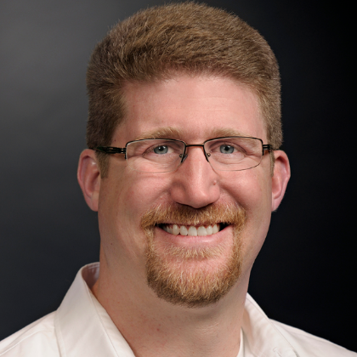 | LaTESOL Conference –  November 2, 2018  Robert Schoenfeld  Director, Global Education Center  Arizona State University  Self-described  English teacher, linguist, language geek, cigar smoker, rugby player, maiden fan, rabble-rouser, instigator, Gemini
10:10 – 11:00 AM Location: Ballroom

WORKSHOP PART 1

STRATEGIES FOR EFFICIENT AND EFFECTIVE WRITING ASSESSMENTS: OR, HOW I TRY TO AVOID NARCOLEPTIC EPISODES WHILE GRADING
Part 1 – Types of Assignments and Methods of Feedback
Description: In Part 1 of this 2-part workshop, Bob discusses the challenges with teaching writing with a focus on the types of assignments and feedback given to students. He has in-session exercises on types of assignments, their benefits and disadvantages, and the methods used to give feedback.
11:00 AM – 12:20 PM Location – Ballroom

WORKSHOP PART 2

STRATEGIES FOR EFFICIENT AND EFFECTIVE WRITING ASSESSMENTS: OR, HOW I TRY TO AVOID NARCOLEPTIC EPISODES WHILE GRADING
Part 2 – More on Feedback, Grading and Rubrics
Description: In Part 2 of this 2-part workshop, Bob continues to address feedback and its consequences. He also dives more deeply into grading and the use of rubrics, emphasizing transparency and efficiency.
Bob Schoenfeld is originally from New York, he has been teaching ESL around the world since 1999. With a Masters in ESL from Mercy College in NY, and in Linguistics from the University of Pittsburg, Bob’s specialty is integrating the how of teaching ESL with the linguistic what that students need to learn to be successful language learners. He has used this fusion of disciplines to instruct elementary students in the Bronx, high school and university students in Japan, engineers from INTEL in Vietnam and rugby players in Canada.
Bob is now at Arizona State University, where he is the Executive Liaison for International Student Services and Director of the Global Education Center for the W. P. Carey School of Business. Bob’s workshops at the International TESOL conference in Chicago this year garnered rave reviews and sitting-room-only attendance.

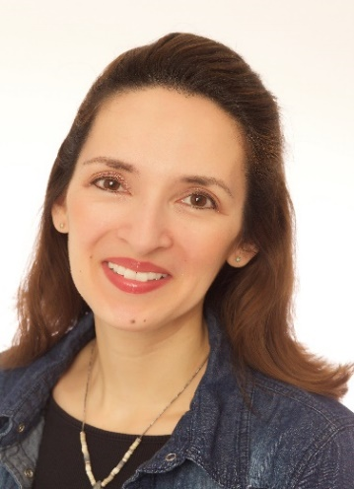 | LaTESOL Conference –  November 2, 2018  JENNIFER LEBEDEV  Jennifer ESL
10:10 – 11:00 AM
Location Room 206

WORKSHOP PART 1
USING AND MAKING VIDEOS TO CREATE, ENHANCE OR FLIP CLASSES
Part 1 – Incorporating Videos into Class Plans
Online ESL videos are readily available, but how exactly can they enhance the classroom experience? In this first part of the workshop, attendees will learn how instructional videos can inform teaching and extend learning. The presenter will share free resources and practical tips that classroom teachers can immediately put into use.

11:00 AM – 12:20 PM
Location – Room 206

WORKSHOP PART 2
USING AND MAKING VIDEOS TO CREATE, ENHANCE OR FLIP CLASSES
Part 2 – Making Videos for Your Classes
Description: Why should you make your own instructional videos? What skills and equipment do you need to get started? In this second part of the workshop, attendees will learn the basics of video-making, from scriptwriting to editing. The presenter will share models and recommendations based on over ten years of experience as a YouTube English teacher. JenniferESL's videos are a staple in many high schools and IELPs. The English with Jennifer YouTube channel has over 700,000 subscribers! Her website and blog offer resources for students and teachers alike.
Afternoon Session: BUILDING LISTENING AND SPEAKING SKILLS FOR EFFECTIVE COMMUNICATION: A YOUTUBER’S APPROACH
Time: 2:30 – 3:20 PM Location: Room 203

Description: In this session, Jennifer takes a YouTuber’s approach to building skills and demonstrates the strategies to make this important medium work for teachers and students.

LaTESOL Conference – November 2, 2018

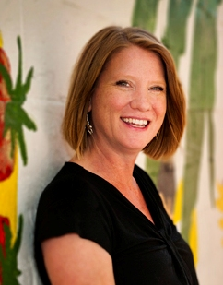

Dr. Stacy Overstreet

12:15 – 1:20 PM

Location: Ballroom

LUNCHEON ADDRESS

CREATING TRAMA-INFORMED SCHOOLS: RATIONALE FOR USE WITH ELLs.

Description: Dr. Overstreet is the Principal Investigator on a grant funded by the National Institute of Justice to determine whether a multi-component implementation strategy for trauma-informed schools improves school safety by aligning staff attitudes, beliefs, and behaviors with a trauma-informed approach. The project includes partnerships with six New Orleans public schools and community organizations including Children’s Bureau of New Orleans, Louisiana Public Health Institute, and Project Fleur-de-lis.

Dr. Overstreet will address the findings from her research and the observations gained in teacher training programs, particularly those addressing the intersection of her work and English Language Learners.

Dr. Stacy Overstreet received her Ph.D. in School Psychology from Tulane University, where she has been a faculty member for 23 years. She has experience creating, implementing, and evaluating school-based mental health services for youth exposed to trauma. Dr. Overstreet has conducted numerous studies on the impact of trauma on child development and the effectiveness of trauma treatments, and she has published manuscripts advocating for school-based mental health services for students exposed to trauma. As Co-PI on a U.S. Department of Education Leadership Personnel Preparation grant, she developed a specialized training program in Trauma Focused School Psychology that is recognized through a certificate program at Tulane. She is also a founding member of the New Orleans Trauma-Informed Schools Learning Collaborative, which provides support to five public schools in the development and use of trauma-informed approaches by bringing together experts in education, mental health, social service, research, program evaluation, and public health.

LaTESOL Conference Day – November 2, 2018
CONCURRENT SESSIONS
11:00 AM – 12:20 PM
BOB SCHOENFELD WORKSHOP PART 2  STRATEGIES FOR EFFICIENT AND EFFECTIVE WRITING ASSESSMENTS: OR, HOW I TRY TO AVOID NARCOLEPTIC EPISODES WHILE GRADING  Location: Ballroom  Intended Audience: All; Assessment  Description: This is a continuation of the morning workshop, with additional emphasis on rubrics and fast grading techniques. |  | JENNIFER LEBEDEV WORKSHOP PART 2  USING AND MAKING VIDEOS TO CEATE, ENHANCE OR FLIP CLASSES  Location: Room 206  Intended Audience: All  Description: This is a continuation of the morning workshop, with additional emphasis and hands-on making and using videos.
GLOBALMINDEDNESS IN NATIONAL GEOGRAPHIC CERTIFIED EDUCATORS  AMY PAN  Location: Room 203  Intended Audience: All  Description:  This program is based on the Ph. D. Dissertation Proposal. The research is based on globalmindedness in National Geographic Certified Educators and non - National Geographic Certified Educators. The Globalmindedness Scale (GMS) was developed by Jane Hett (1993). |  | USING STORYBIRD TO ENHANCE STUDENT WRITING  B “AJO” STEWART  Location: Room 204  Intended Audience: Elementary Ed; Writing  Description: Tap into students’ love of technology and unleash their creativity using Storybird.com This hands-on workshop walks participants through the process of creating class assignments and teaching students how to write and share their stories. One of the reasons this platform is so engaging is that artists upload their images for writers to use. The end result is a beautifully illustrated written work that students and teachers can be proud of.
CONCURRENT SESSIONS
1:30 – 2:20 PM
INTERPRETING ELPT RESULTS  ELPA21 and Beverly Diaz, Louisiana Department of Education  Location: Room 202  Intended Audience: K-12 |  | Comprehensible Input and The SIOP® Model  Andrea “Annie” Rients, Pearson Learning  Location: Room 203  Intended Audience: K-12  Description:  In this session, we will delve into SIOP® Model component, "Comprehensible Input" and consider effective instructional practices that build on students' assets and experiences.
THE POWER OF LANGUAGE FOR LIFELONG SUCCESS  JESSICA BORDELON  Location: Room 204  Intended Audience: Intercultural Communications, All Levels  Description: This session encourages teachers to not only present grammar skills and vocabulary but to also use their own cultural knowledge and experience to explain the underlying meaning implied with each language skill. In this workshop, various grammar forms and vocabulary will be presented to attendees for discussion and creation of a sample lesson plan that can be used in the classroom. Attendees will build lesson planning skills they can apply to their language classrooms. |  | Effectiveness of 8-week intervention strategies for Panamanian English teachers  JOHN DePRIEST  Location: Room 205  Intended Audience: Higher Ed  Description: The Ministry of Education of Panama has instituted a program called Panama Bilingue where English language teachers are sent to predominantly English speaking countries for immersive language and teacher training sessions lasting either 8 or 16 weeks. This talk will assess the effectiveness of one of the 8-week programs using measures of phonemic accuracy and fluency from recorded interviews conducted at the beginning and end of the program.
UNLOCKING ELS’ POTENTIAL THROUGH THE TEACHING OF ACADEMIC LANGUAGE

Time: 1:30 to 2:20 PM

Location: Room 206

Description: During this session, participants will explore why the explicit teaching of academic language to ELs is essential for their acquisition of language and content. Participants will learn and apply strategies for teaching academic language at the word, sentence, and discourse level.

CONCURRENT SESSIONS
2:30 – 3:20 PM
INTERACTIVE VOCABULARY ACQUISITION METHODS FOR INTERMEDIATE TO ADVANCED ENGLISH LEARNERS  KAREN JACKSON & BETHANY NEPTHUNE  Location: Room 202  Intended Audience: Methods; Adult Ed  Description: This presentation will explore alternative methods of vocabulary instruction geared toward adult learners with diverse needs. We will discuss student-driven, project-based assignments suitable for use across levels in reading, writing, listening and speaking classes. We will share examples and templates for vocabulary presentations and discuss successes and failures in implementation. Extension projects and materials for self-study will also be discussed. |  | BUILDING LISTENING AND SPEAKING SKILLS FOR EFFECTIVE COMMUNICATION: A YOUTUBER’S APPROACH  JENNIFER LEBEDEV  Location: Rom 203  Intended Audience: Listening & Speaking; Adult Ed  Description: Single video lessons and whole video playlists can serve as an on-demand resource for learners. The presenter will model a sequence of YouTube lessons that combines independent study and classroom practice in order to build listening and speaking skills. Attendees will receive a list of recommended tools and resources that can help learners become confident communicators.
WHY TEACH WITH THE HELP OF IMAGINE LEARNING? IT’S NOT JUST FOR ENGLISH LANGUAGE LEARNERS  ELIZABETH THOMPSON AND JOHN EDWARDS, IMAGINE LEARNING  Location: Room 204  Intended Audience: Elementary Ed; K-12  Description: All teachers have access to all of the printable stories and lesson plans offered in the program. With just a click of the mouse, a teacher has access to books on all reading levels. The students can work on this as a group or individually. Say goodbye to one-size-fits-all instruction and hello to a strategic, research-based curriculum that meets students at their own level.  STRATEGIC OPTIONS FOR SELECTING LITERARY WORKS IN THE ESL CURRICULUM  DR DAMIEN HINOJOSA  Location: Room 205  Intended Audience: Curriculum Development; Reading  Description: This presentation focuses on aspects for consideration when selecting literature for ESL courses. The goal is to challenge Instructors to consider and validate a student’s previous experience with symbols, metaphors, imagery, and universal experiences when studying literature. This presentation recommends using literary works that not only address universal human experiences but also |  | UPDATE ON IMMIGRATION LAW  CAROLINE BARNES, IMMIGRATION ATTORNEY  Location: Room 206  Intended Audience: All  Description: Caroline Barnes, a noted immigration attorney in the Baton Rouge area, will provide an update on immigration legal issues and also answer some common questions about rights and responsibilities of students, families and teachers.  Barnes privately represents clients worldwide for United States immigration matters, including, but not limited to, family-based immigration, K-1 fiancé(e) and marriage-based visas, permanent residence, citizenship and naturalization, Consular Processing, Asylum, U-Visas, and Temporary Protected Status (TPS). She has helped hundreds of clients reach their immigration goals.  works that require less contextualization due to the nature of the title, the theme or the implicit conflict.

PRESENTER BIOS
Crystal Arceneaux | Crystal is the EL and Parent Coordinator for Iberia School District. She has served Iberia for 24 years in various capacities: teacher, TAP master teacher, curriculum coordinator and administrator. Crystal was an ESL teacher and administrator of Iberia’s summer program, Camp E.L.I.TE., for English learners. She partnered with the University of Louisiana at Lafayette to build capacity in teachers of English learners through an EL coaching model. Today, Crystal is presenting curriculum scaffolds that she, along with other ESL teachers, authored for LDOE’s ELA Guidebooks.
Caroline Barnes | Ms. Barnes was born and raised in Houston, Texas. She is currently a member of the American Immigration Lawyers Association (AILA) and the Louisiana State Bar Association. She obtained her bachelor’s degree from Louisiana State University in 2010, graduating summa cum laude, and her Juris Doctor and Graduate Diploma in Comparative Law from Louisiana State University Paul M. Hebert Law Center in 2013. During her undergraduate years, she was a member of the LSU Honor’s college, Delta Gamma fraternity, and Kappa Tau Alpha (Mass Communication Honor Society). During her law school career, Ms. Barnes gained significant experience in the practice of immigration law. She participated as a student attorney with the LSU Law Immigration Clinic and interned with Catholic Charities Diocese of Baton Rouge Immigration Legal Services. As a student attorney with the LSU Law Immigration Clinic, Ms. Barnes represented clients for family-based immigration matters including U-Visas and VAWA. Ms. Barnes now privately represents clients worldwide for United States immigration matters, including, but not limited to, family-based immigration, K-1 fiancé(e) and marriage-based visas, permanent residence, citizenship and naturalization, Consular Processing, Asylum, U-Visas, and Temporary Protected Status (TPS). She has helped hundreds of clients reach their immigration goals.
Angela Bradley | Angela Bradley, a doctoral student in the Educational Leadership program at Louisiana State University, currently serves as an elementary school principal in the Jefferson Parish Public School System. With 12 years of teaching experience, she is Louisiana certified to teach grades 1 – 8, English as a Second Language, and Spanish: World Languages (grade K – 12). Angela Bradley’s rich experiences as an educator, expatriate, and traveler have ignited her passion in second language acquisition.
Ron Caron | “Mr. Ron” teaches secondary public school ESL in the New Orleans area since 2010, and taught Sheltered English in a Los Angeles public school from 2002-2010. He has a B.A. and ESL certification from UNO. His classroom philosophy is kindness and love, along with speaking, and daily writing; his hero is Mr. Rogers. He also teaches the rudiments of music in an afterschool ukulele club.
John DePriest | John DePriest earned a PhD in Linguistics from Tulane University in 2015 with an emphasis on using electrophysiology to investigate phonological and syntactic integration impairment in autism spectrum disorder. He now teaches ESL and ESL certification courses at Tulane and around New Orleans, including speaking and writing courses, and Structure of English for Teaching. His primary interests and fields of research include phonetics, phonology/syntax interactions, neurolinguistics, language disorders, music cognition, and musical grammars. When not teaching he investigates music and language interaction through songwriting, and plays banjo for several musical groups around New Orleans.
Beverly Diaz | Beverly Diaz is the Director of English Learner and World Language programs for the LDOE.
Wayne Eichen | Wayne served as a consultant to the New York State Department of Education as a teacher on assignment and ran numerous state workshops related to technology and instruction. He also served as an instructional technology coach in the Sarasota, Florida School system, for 3 years, and helped facilitate a one year 27-point increase in student FCAT math scores, at a Title 1 school with a high ELL population. He has been dedicated to using technology to increase student achievement for over 30 years, in several capacities in both the private and public sector, and currently serves as the National Account Executive for Intervention programs at Pearson.
Marissa Bejarano- Fernbaugh | Marissa Bejarano-Fernbaugh is a first-generation Mexican-American from the border town of Nogales, Arizona. Marissa is currently a high school EL specialist in Ascension Parish. She received her B.A. in Political Science from the University of the Incarnate Word in San Antonio, Texas and will be receiving her M.E.d. in Curriculum and Instruction in ESL in December from Louisiana State University-Shreveport. Marissa lived in Europe until her early teens before moving back to Arizona. She also attended a language program in Cuernavaca, Mexico and spent her junior year of college studying Japanese at Kumamoto University in Kumamoto, Japan. Marissa’s passion for experiencing other cultures and her love of education compels her to continue her work on behalf of immigrant and English Language learning populations. She considers herself honored to have the opportunity to work with English language learners and is honored to be part of their language acquisition journey.
Monica Vaughn-Flam | Monica Vaughn-Flam is a K-12 English as a Second Language (ESL) Program Manager who believes in teaching English in a way that is meaningful and relevant, so that students embrace its importance and leverage their deep passion for learning a new language to influence the world around themselves. Monica has created the ESL Program for KIPP New Orleans where she has developed and implemented instructional and administrative policies. A constant advocate for students and families, Monica works tirelessly to ensure students have access to an excellent education. Monica holds a B.A. in Psychology and Human Development from The University of Connecticut and a Master of Education from Johns Hopkins University.
Damian Hinojosa | Damian Hinojosa is Chair of Languages, Literature, and Fine Arts at St. Joseph Seminary College. He received a B.A. in Spanish Literature from St. Thomas University in Houston. He earned the M.A. in Spanish Literature from Middlebury College and a Master of Divinity from the University of Toronto. He earned the Ph.D. in Medieval Literature from the University of Texas.
Alexandra Horner | Alexandra Horner is an ESL Instructional Specialist with the East Baton Rouge Parish School System. Prior to becoming an Instructional Specialist in 2011, she was an ESL teacher for 4 years. She earned her Bachelor’s Degree from Columbia University, NYC in 1999, and became ESL Certified in 2006. She has been in the ESL Department for 12 years, with 16 years in the teaching profession.
Karen Jackson | Karen Jackson is an ESL instructor at Loyola University’s Intensive English Program. She earned her TESOL certification from SUNY Westchester and has also studied education, fine art and philosophy. She has taught in 5 countries across all ages and skill levels. Outside of the classroom she enjoys music, nature and being a mom.
Jennifer Kelly | Jennifer is the Migrant Education Program coordinator and coaches teachers in EL strategies in Union Parish. She has completed 2 international fellowships in Costa Rica and Indonesia. In 2014 she completed a second master’s degree in Ed Leadership with TC, Columbia University. She has been working with ELs for 5 years.
Sharon Moscoso | Sharon Moscoso is the Education & Literacy Program Manager under Catholic Charities Immigration and Refugee Services. She has been with the program since 2012 holding all positions at one time or  another during her time with the program. She currently oversees educational programming for more than 900+ students a year with the help of 350+ volunteers. Services include: English as a Second Language classes, citizenship classes, and more recently family literacy component to address the educational needs of immigrant families with a holistic approach.
Bethany Neptune | Bethany Neptune is currently an ESL instructor for the Loyola Intensive English Program in New Orleans. She earned her Master’s degree in TESOL from the State University of New York at Albany, where she also worked as a writing instructor and conducted research on second-language writing. She has taught traditional and online courses in both the United States and China for college students and adult learners.
Amy Pan | Amy Pan is an ESL Instructional Specialist with the East Baton Rouge Parish School System. She is a National Geographic Certified Educator and is completing her Ph. D. at Louisiana State University. Pan was selected to attend Harvard University's “Think Tank on Global Education.” Her research focuses on global mindedness.
Annie Rients (Pearson SIOP®) | Annie Rients is the Professional Learning Coordinator for Shakopee Public Schools in Shakopee, MN. Annie has been a classroom teacher, instructional coach, district wide mentor coach, professional developer and a Pearson Educational Specialist on the SIOP® Model for 15 years. She received a Master’s in Teaching and Learning from St. Mary's University and has been a contributor in both the 99 More Ideas for Teaching English Learners with the SIOP Model and the SIOP Manual. She has provided professional development for teachers, coaches and administrators across the country and works directly with the SIOP® Authors to develop and facilitate high quality professional development around the SIOP® Model.
Judith “Cissy” Rowley | As the ESL Chair at St. Martin’s Episcopal School, I coordinate curriculum for our international students in grades 5-12. I previously worked with both ELL and French immersion students, but currently teach high school French I to AP with a strong emphasis on speaking and participation. I have an M. Ed and an MA in French from Middlebury College. I love teaching language because I find it so interesting!
Bethann “Ajo” Stewart | Ajo received her TESOL certificate from the New School for Social Research in New York City in 1996. Since then, she has taught all levels of ESL - from kindergarten through university and adult education. She holds an M.A. from SUNY Albany and an MAT from George Fox University. She is the author and designer of an interactive textbook for ELs, and a teacher-consultant for the Greater New Orleans Writing Project. Before committing to full-time teaching, Ajo was an award-winning journalist.
Denise Thomas | Denise Thomas is an EL specialist in Ascension Parish. She has an undergraduate degree from LSU and is currenting working towards her master’s degree in Curriculum and Instruction ESL at LSUS. Denise has been teaching for 15 years. Denise is former EL student whose family is originally Costa Rica.
Elizabeth Thompson | Elizabeth is Title III Coordinator for St. John the Baptist Parish. She has been teaching for 24 years, and the last four years were teaching English learners from kindergartners to high school. Her job now allows her to not only service many ELs, but their parents as well.
Rebecca Tullos | Rebecca De Luna Tullos is a former EL student from EL Paso Texas. She is a proud LSU graduate and is now an EL Specialist in Ascension Parish. Rebecca is working towards her Master of Educations in Curriculum and Instruction focusing in English as a Second Language. She has a passion for empowering students to achieve academic success while acquiring the English language.
Curran Wallace | Currin Wallis is a bilingual case manager for the Unaccompanied Children’s Program with Catholic Charities Archdiocese of New Orleans. She has worked with the program since the spring of 2017 and has taken the lead on education advocacy in the greater New Orleans area. Currin’s experience as a case manager working directly with newcomer and recently reunited families has given her insight into the EL student and parent experience in the Jefferson and Orleans Parish school system, and she has worked collaboratively to educate families, empower parents to advocate for their children, and spearhead a greater push for policy change from higher stakeholders in the school districts.

This Photo by Unknown Author is licensed under CC BY-SA-NC
AND A HUGE THANKS TO OUR SPONSORS & PUBLISHERS

BBB Educational Enterprises, Inc.
Elizabeth Claire, Inc./Easy English NEWS
Brenda Custodio/Corwin
Holmes Educational Consultants
Okapi Educational Publishing
Sydney Snyder/SupportEd

List of Past LaTESOL Presidents

1. Gail Acree, 1980-81, Louisiana State University
2. Edith Babin, 1981-82, Louisiana State University
3. Mary Ruetten, 1982-83, University of New Orleans
4. Mary Ann Lennon, 1983-84, Delgado Community College
5. Julia Barnes, 1984-85, Jefferson Parish Public Schools
6. Joan Fields, 1985-86, University of Southwestern Louisiana
7. Linda Blanton, 1986-87, University of New Orleans
8. Bonnie Keller, 1987-88, University of New Orleans
9. Joan Kelly, 1988-89, Louisiana State University
10. Joel Phillips, 1989-1990, Jefferson Parish Public Schools
11. Karen Lewis, 1990-1991, Louisiana Tech University
12. Kathleen Carlin Kilborne, 1991-92, O. Perry Walker High School
13. Eleanor Howes, 1992-93, Louisiana State University
14. Robbie Phillabau, 1992-93, Louisiana State University
15. Barbara Gaffney, 1993-94, University of New Orleans
16. Elin Epperson, 1994-95, Louisiana State University
17. Margaret Fremin Burkart, 1995-96, Jefferson Parish Public Schools
18. JoAnn Robicheaux, 1996-97, Southeastern Louisiana University
19. Cathy Cake, 1997-98, Tulane University
20. Yadira Diaz, 1998-99, Delgado Community College
21. Lia Kushnir, 1999-2000, University of New Orleans
22. Georgette Ioup, 2000-01, University of New Orleans
23. Carolyn Sanchez, 2001-02, Jefferson Parish Public Schools
24. Brian Ary, 2002-03, University of New Orleans
25. Susan Ary, 2003-04, University of New Orleans
26. Jeanne Stacy, 2004-06, Baton Rouge Community College
27. Mary Klaus, 2006-07, University of Louisiana at Lafayette
28. Mark Honegger, Ph.D., 2007-08, 2009, University of Louisiana at Lafayette
29. Robert Connor, 2008-09, Louisiana State University
30. Denise Marceaux, 2009-10, University of Louisiana at Lafayette
31. Gretchen Shotwell, 2010-11, Jefferson Parish Public Schools
32. Elizabeth Anderson, 2011-12, Our Lady of Holy Cross College
33. Kimberly Navarro, 2012-13, Delgado Community College
34. Karen Seamans, 2013-14, Livingston Parish Schools
35. Robert Connor, 2014-15, Tulane University
36. Esther Perez-Zemmels, 2015-16, Jefferson Parish Public School System
37. Jody Garcia, 2016-17, Consultant
38. Christina Indovina/Carolyn Jones, 2017-18, University of New Orleans, Tulane University

